DENVER RTD EAGLE P3
COMMUNICATION SYSTEM

FIELD MODIFICATION INSTRUCTIONS
FMI #16: PA announcement

software updates.
CONTRACT NO. | P110701149
CDRL NO. | N/A
WIS DOC. NO. | 42A-2017-0068
REVISION: | 1.0
DESIGNED: | D. S. JANG
REVIEWED: | J. Y. LEE
APPROVED: | B. J. JONE
DATE: | 7/18/2017



Record of Revisions
Rev. | Date | Description | Entered By
1.0 | 7/18/2017 | Initial release | D. S. Jang

Table of Contents
1. Introduction 4
2. Summary 4
3. Instructions 4
3.1 Location of Equipment 4
3.2 Software Update DESCRIPTION 6
3.2.1 Algorithm Block Diagram 6
3.2.2 Current Issue 7
3.3 VERSION ChECK 7
4. Tracking 8

Introduction
This FMI provides instructions to install the Communication System update to the vehicles.

Summary
This FMI applies to following software & Hardware configuration item:
- CCP SW change.

Instructions

Location of Equipment
Following figures show the location of equipment to be updated.
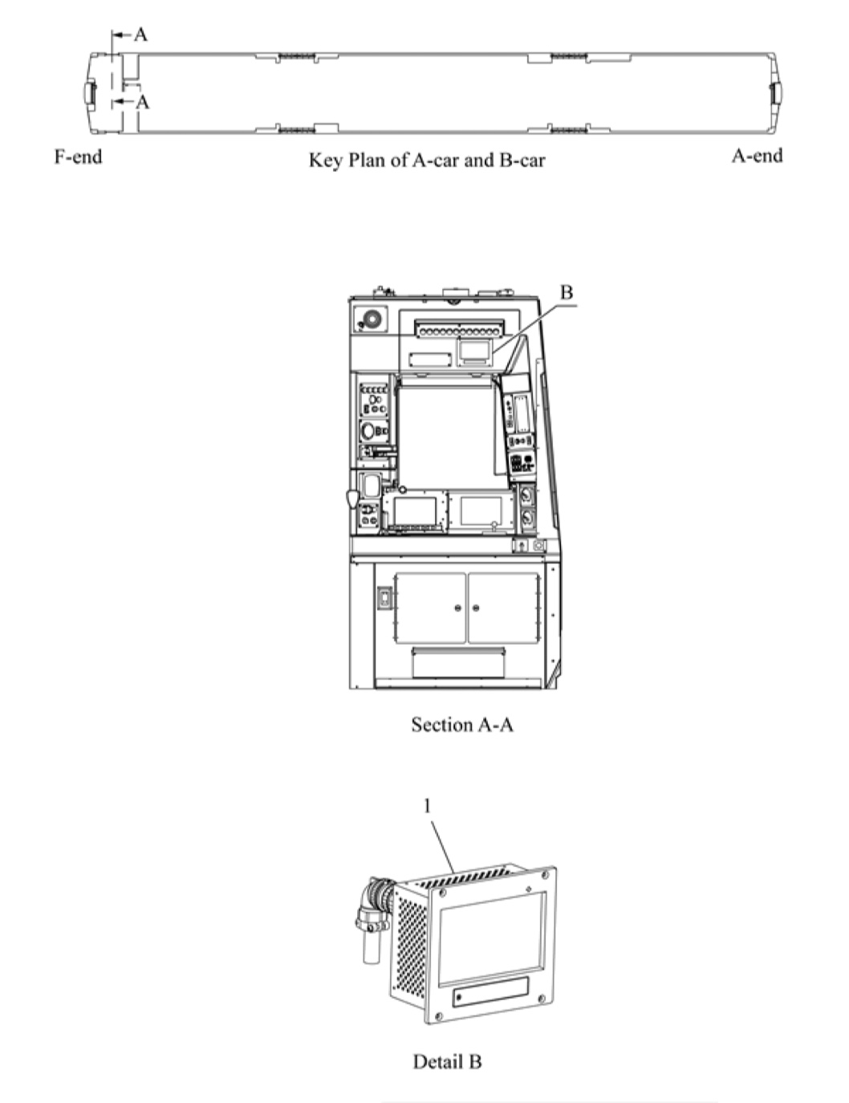
Figure 1 – CCP Location

Software Update DESCRIPTION

Algorithm Block Diagram
- Receives GPS data from PTC via Ethernet communication.
- The CRA identifies the GPS data corresponding to the car among the Ethernet data and converts it into 485 communication.
- The CCP retrieves the schedule data received by 485 communication GPS data. According to the search result, PA information is transmitted to the CRA.
- The CRA plays the PA and play information is shared with the PAC-MCU. The PA is output to the speaker through the AMP.

Current Issue
1) Before Change.
: Currently, the CCP does not check the GPS data information provided by the CRA.

2) After Change.
: The GPS data received from the CRA is confirmed by the filter algorithm and if it is determined that the data is abnormal, it communicates with the rear CRA to process the information

SOFTWARE UPDATE
1) Connect the CCP and a PTU laptop with a USB cable.
2) Copy the updated ‘AnCCP_MFC.exe’ to CCP directory: Root\NandFlash\
3) Recycle COMCB to apply the update.

TEST AND VERIFICATION
After updating the CCP software, follow the procedure below to verify the functionality:
1) Key-on the cab
2) Using the CCP touchscreen, enter route number 10 or 11
3) Run the route simulation
4) Verify the simulated announcements and displays function appropriately.

VERSION ChECK
Use the MDS Software Version menu to verify the updated software versions.
- CCP : 1.0.06

Tracking
Status of the field modification activities will be tracked and managed for car number and items completed. The progress will be reported to DTP/H-Rotem in daily basis as the modification proceeds.

